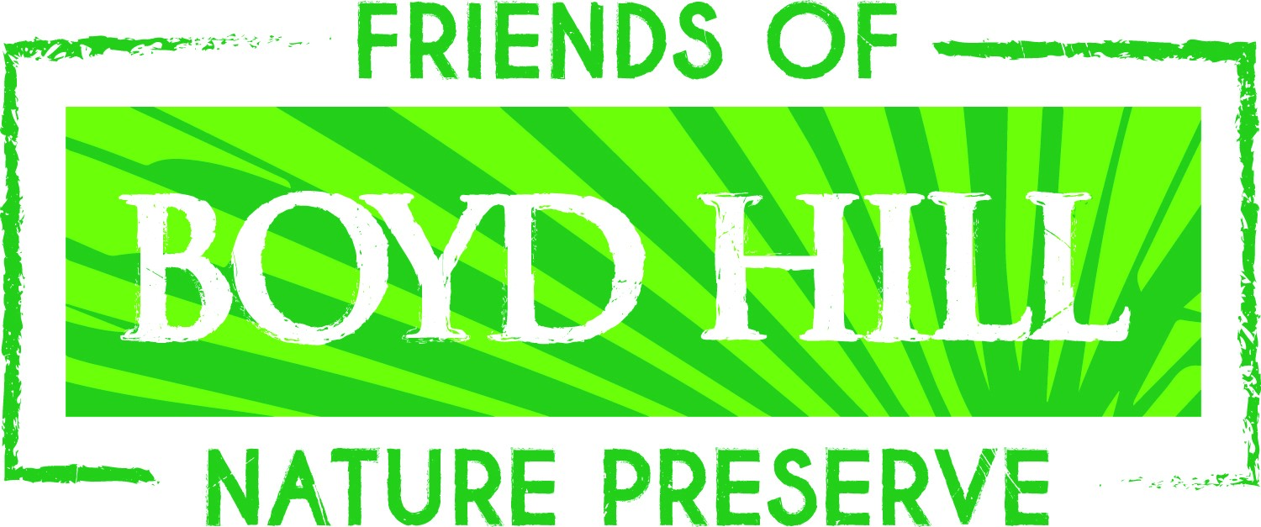
Boyd Hill Nature Preserve

Scholarship Nomination Information

Dear Teacher,

The Friends of Boyd Hill Nature Preserve are pleased to offer Summer Camp scholarships for students of low income families. We would like you to recommend children who have special interest in and would like to experience hands on activities with nature.

Scholarships are available for the following camps:

Young Naturalist – Ages 5 - 6
Nature Adventure Camp - Ages 7 – 13
Raptor Camp – Ages 8-12

In order to be eligible for a scholarship, the nominee must meet the following criteria:

- Entering grades K - 8
- Qualify for the free or reduced lunch program
- Have a current ADVANTAGE membership (FREE)

To nominate a child, please complete the following steps:

- Nominator and the student complete the nomination form.
- Parent or Guardian completes the camp application form. Please choose a camp according to child’s age.
- The Nominator should return the nomination form, camp application form and Waiver to:
Camp Scholarship Committee
c/o Boyd Hill Nature Preserve
1101 Country Club Way S
St Petersburg, FL 33705

- Nomination Forms and camp applications are due by April 21, 2017.

The parent/guardian will be notified of acceptance and the date your scholarship is awarded by April 28, 2017.

These scholarships are made possible by the Friends of Boyd Hill Nature Preserve, Inc. through generous contributions from local businesses, organizations, and private donors. Donations for the camp scholarships are still being accepted and can be mailed to the same address as listed above. Checks are to be made payable to Friends of Boyd Hill.

Thank you for your time and interest. Should you need additional information, feel free to contact Boyd Hill Nature Preserve at (727) 893-7326 or bhpreserve@stpete.org.

Boyd Hill Nature Preserve’s Summer Camp Scholarship Nomination Form

To be eligible, the nominee must meet all qualifying criteria (see nomination letter). In addition, all forms must be filled out completely and returned to the scholarship committee no later than April 21, 2017.

Child’s Name ______________________________________________ Age _____________

Entering Grade ___________ School ____________________________________________

Parent or Guardian’s Name ____________________________________________________

Address ___________________________________________________________________
(Street) (City) (Zip)

Home Number ___________________________ Work Number _______________________

Nominator’s Name ___________________________________________________________

Relationship ________________________________________________________________

Email Address ______________________________ Phone Number __________________

Nominator’s comments on why this student should be awarded a scholarship to
Boyd Hill Nature Preserve’s Summer Camp.

_________________________________________________________________________________________________________________________________________________________________________________________________________________________________________________________________________________________________________________________________________________________________________________________________________________________________________________________________________________________________________________________________________________________________________________________________________________________________________________________________________________________________________________________________________________________________________________________________________________________________________________________

Feel free to attach additional pages

I hereby certify that this child qualifies for the free or reduced lunch program.

Teacher’s Signature________________________________________________.

Boyd Hill Nature Preserve’s Summer Camp

Scholarship Nomination Form - page 2

Students comments - Tell us why you would like to attend
Boyd Hill Nature Preserve’s Summer Camps

Feel free to attach additional pages

Summer Camp Registration 2017
Boyd Hill Nature Preserve

Please Print - one application per child/per camp. You may duplicate as needed.

Child’s Name ________________________________________________________________ Age ___________

Address___________________________________________________________Home Phone_______________

City ____________________________ State _________ Zip ________________Cell Phone ________________

Parent/Guardian Name ___________________________________________Work Phone___________________

Parent/Guardian Name___________________________________________ Work Phone____________________

Email address__________________________________________ ADVANTAGE card #____________________

Emergency Contact _____________________________________ Emergency Phone ______________________

Second Contact (do not list parent, guardian or emergency contact in this area - relation can be friend, Aunt, Uncle etc.)

Name ______________________________ Relation__________________ Phone Number__________________

Allergies or Medication of Child _________________________________________________________________
(Be sure to complete the medication form if any type of medication needs to be dispensed.)
Who will be dropping off/picking up your child?___________________________________________________

Please designate your first and second choice of the camp attending. One camp per form.

Camp times are 9:00 a.m. – 4:00 p.m. Monday-Friday. Extended care (8:00 a.m.-5:00 p.m.) is available for $25.
(Place #1 or #2 next to the appropriate date)

Young Naturalist (Age 5-6) Nature Adventure Camp (Age 7-13) Raptor Camp (Age 8-12)

__ May 30-June 2  __ June 5-9  __ June 12-16  __ June 19-23  __ June 26-30  __ July 3-7 (closed July 4th)  __ July 10-14  __ July 17-21  __ July 24-28  __ July 31-Aug 4 | __ May 30-June 2 __ June 19-23  __ June 5-9 __ June 26-30  __ June 12-16  __ June 19-23  __ June 26-30  __ July 3-7 (closed July 4th)  __ July 10-14  __ July 17-21  __ July 24-28  __ July 31-Aug 4

The child and the parent and/or guardian hereby acknowledge that the above named child may not attend this program unless the child and the parent and/or guardian agree to and sign the City of St Petersburg’s Release, Waiver of Claims, Hold Harmless and Indemnity Agreement, and that upon its execution, such document shall be incorporated with and shall become a part of this registration application.

Parent/Guardian
Signature________________________________ Print Name______________________________ Date _________________

Staff Use Only
Date Processed_____________ Staff initials ___________ Cash __________ Check # _________ Charge _________

